**Project Design Phase-II**

**Data Flow Diagram & User Stories**

|  |  |
| --- | --- |
| Date | 23 May 2025 |
| Team ID | LTVIP2025TMID31767 |
| Project Name | Citizen AI - intelligent citizen engagement platform |
| Maximum Marks | 4 Marks |

**Data Flow Diagrams:**

A Data Flow Diagram (DFD) is a traditional visual representation of the information flows within a system. A neat and clear DFD can depict the right amount of the system requirement graphically. It shows how data enters and leaves the system, what changes the information, and where data is stored.



**Example:** [**(Simplified)**](https://developer.ibm.com/patterns/visualize-unstructured-text/)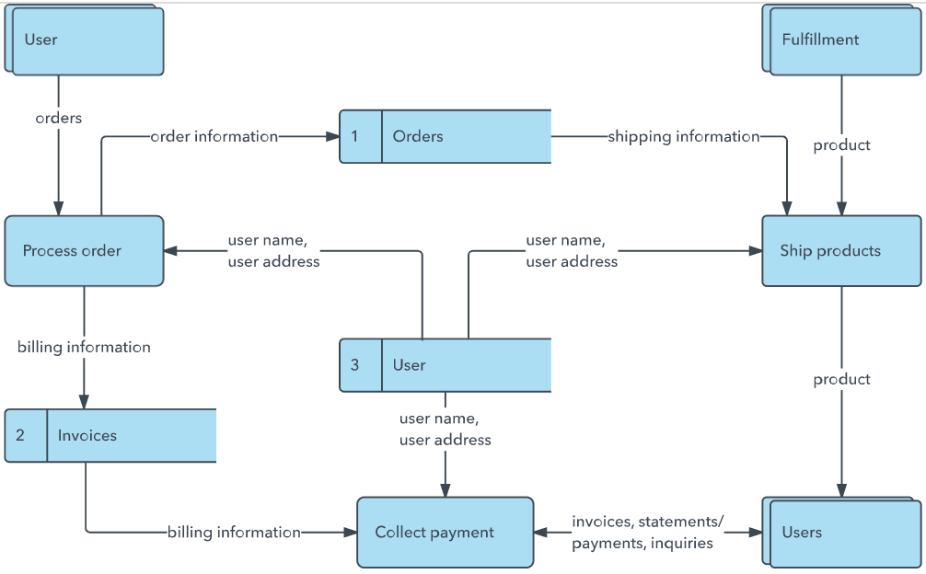

**User Stories**

Use the below template to list all the user stories for the product.

| **User Type** | **Functional Requirement (Epic)** | **User Story Number** | **User Story / Task** | **Acceptance criteria** | **Priority** | **Release** |
| --- | --- | --- | --- | --- | --- | --- |
| Customer (Mobile user) | Registration | USN-1 | As a user, I can register for the application by entering my email, password, and confirming my password. | I can access my account / dashboard | High | Sprint-1 |
|  |  | USN-2 | As a user, I will receive confirmation email once I have registered for the application | I can receive confirmation email & click confirm | High | Sprint-1 |
|  |  | USN-3 | As a user, I can register for the application through Facebook | I can register & access the dashboard with Facebook Login | Low | Sprint-2 |
|  |  | USN-4 | As a user, I can register for the application through Gmail | I can register & access the dashboard with Gmail Login | Medium | Sprint-1 |
|  | Login | USN-5 | As a user, I can log into the application by entering email & password | I can successfully log in and access my dashboard | High | Sprint-1 |
|  | Dashboard | USN-6 | As a user, I can monitor aggregated government service ratings and reported issues. | I can easily identify areas needing improvement in service delivery. | High | Sprint-3 |
| Customer (Web user) | Real-Time Conversational AI Assistant | USN-7 | As a citizen using the web platform, I can interact with the AI assistant for inquiries and support. | I can seamlessly engage with the AI assistant on the web interface and get accurate responses. | High | Sprint-1 |
|  | Personalized & Contextual Response | USN-8 | As a citizen, I can receive personalized and contextually relevant responses to my queries. | The AI accurately interprets my query's nuance and provides tailored information. | High | Sprint-3 |
| Customer care executive | Citizen Sentiment Analysis | USN-9 | As a customer care executive, I can view overall public sentiment (Positive, Neutral, Negative) from citizen feedback. | I can quickly identify the public's general feelings about government services. | High | Sprint-2 |
| Administrator | Citizen Sentiment Analysis  Dynamic Dashboard | USN-10  USN-11 | As a customer care executive, I can track emerging issues from aggregated sentiment data.  As an administrator, I can view real-time visualizations of citizen feedback and interaction trends. | I am alerted to new or escalating public concerns based on sentiment.  The dashboard provides clear charts and metrics for understanding public perception. | Medium  High | Sprint-2  Sprint-3 |
|  | Dynamic Dashboard | USN-12 | As an administrator, I can access and manage the underlying data for citizen inquiries and sentiment. | I can ensure data accuracy and privacy for all citizen interactions. | High | Sprint-4 |
|  |  |  |  |  |  |  |